Standard Operating Procedure
For
Oracle Sub-ledger CC Reconciliation

Document History
Document Location
MHE Share Drive
Document Creation
Creation Date: | Genpact approval by: | Customer approval by:
17/06/2016 | Name, Title | Dir AR Operations

Revision History
Revision Date: | Version Number: | Change reason: | Pages Changed (pg. no.) | Genpact approval by: | Customer approval by:
17/06/2016 | 01 |  |  | Name, Title | Name, Title
5/31/2017 |  | Recertification |  |  | Kathleen Luckie
5/23/2018 |  | Recertification |  |  | Kathleen Luckie
12/10/2019 |  | Recertification |  |  | Kathleen Luckie
10/29/2020 |  | Recertification |  |  | Kathleen Luckie
Table of Contents
1. Overview 4
1.1. Customer Overview 4
1.2. Purpose 4
1.3. Scope 4
1.4. Definitions 4
1.5. System Overview 4
1.6. Roles and Responsibilities 5
2. Process Narrative 5

3. Process Map/Flowchart …………………………………………………………………………………….5
4. Detailed Process Steps 5
5 Process Exceptions Handling 22
6. Compliance control 22
7. Escalation process 22
8. Process SLAs 22
9. Related Documents 22
10. FAQ: 22

11 Signoff…………………………………………………………………………………………………………….22

- Overview
  - Customer Overview

McGraw Hill is part of Apollo Inc. a leading provider of Educational information and products. McGraw Hill was founded in 1917 and acquired by Apollo Inc. in March 2013. It provides essential information and insight that help individuals, markets, and societies perform to their potential. The primary goal of the McGraw Hill is to focus our efforts on growing globally, converging content and technology to create new higher-value offerings, and become more productive – Global growth; Digital growth; increased productivity.

  - Purpose
In order to do Credit Card Reconciliation, this report is required to know the exact sales, refunds, reversals which has hit the OTC R12 sub-ledger for a particular month.

This reconciliation report needs to be completed by the 2nd workday

  - Scope
  - Definitions
    - Acronyms

Abbreviation: | Long Form:

    - Definitions

Term: | Definition:

  - System Overview
- Citrix
- Oracle OTC R12
- PayPal website
- Brain Tree website
- Orbital reports
- Excel
  - Roles and Responsibilities

Role: | Responsibility:
Reconciliation Analyst | To segregate the total Sales, Refunds and Reversals for the month by verifying with the sub-ledger balance.

- Process Narrative

This process is used to reconcile the general ledger activity for the cash receipts in Oracle OTC R12.
- Process Map/Flowchart

N/A
- Detailed Process Steps

First day after close

The process starts once the AR month-end Sub-ledger close is completed.

Login to Citrix > Login to Oracle 11i with the credentials and then select the Responsibility “MHE – Receivables Manager1 – USA”

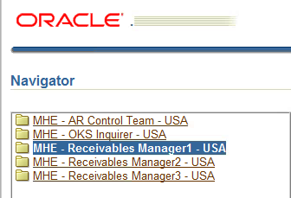

And then Click on Run under the Other : Requests option to Run reports and get variance screen shots on first day for current month processing will change amounts

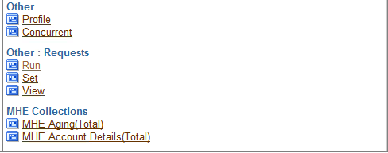

Click on OK
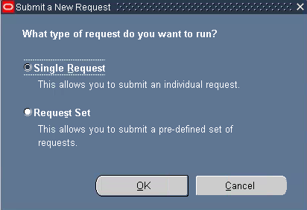

The following window appears:

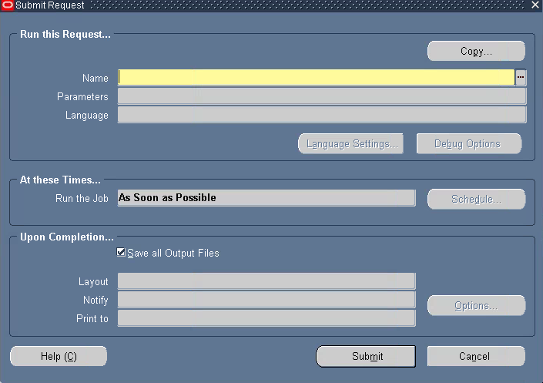

In the Name field type “MHE AR Credit Card Fee Allocation Report” the request to be submitted and press Tab and the following window appears
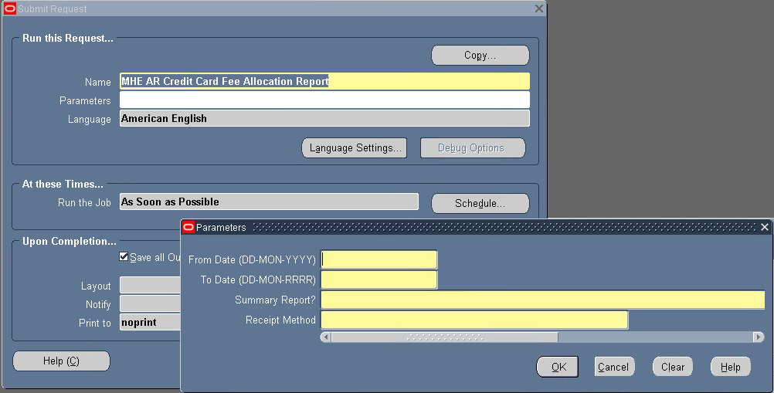

Enter the following details:
From Date (DD-MM-YYYY format)
To Date (DD-MM-YYYY format)
Summary Report (for Detailed report select No)
Select the Receipt Method:

For HPI
USD-CREDITCARD-HPI-02013
USD-CC-HPI-PAYPAL

For SEG
USD-CREDITCARD-SEG-02013
USD-CC-SEG-PAYPAL

Fore Brain Tree
USD_CC_HPI_PAYPAL_AMS

Note: The following example is shown for one payment type but it need to be followed for all receipt methods mentioned above.

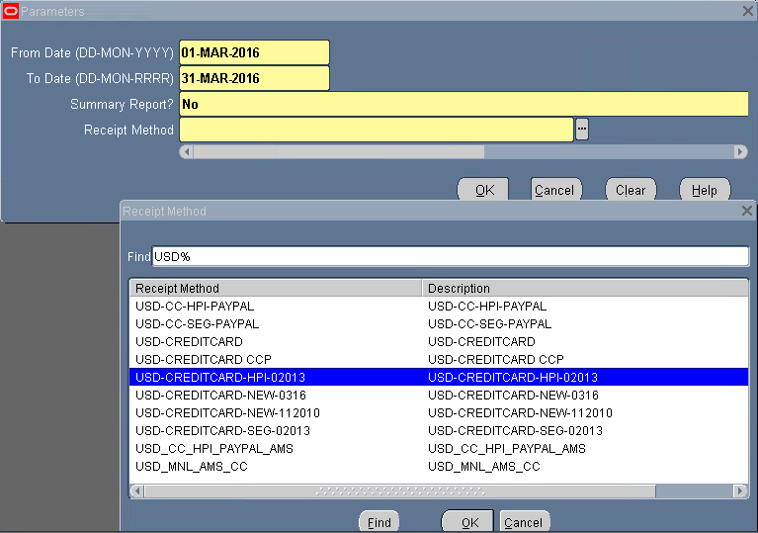

Then Press OK and then Click on Submit and then Click on No
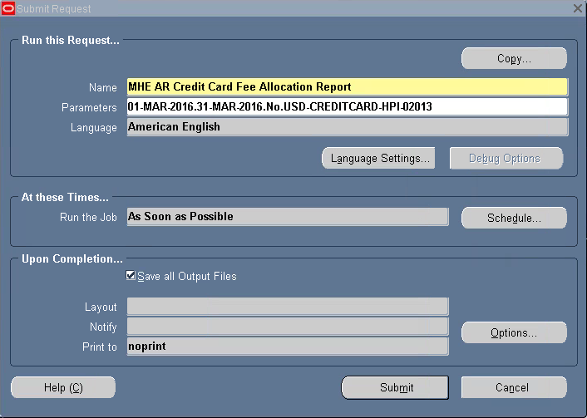

Go to Toolbar and select View click on Requests
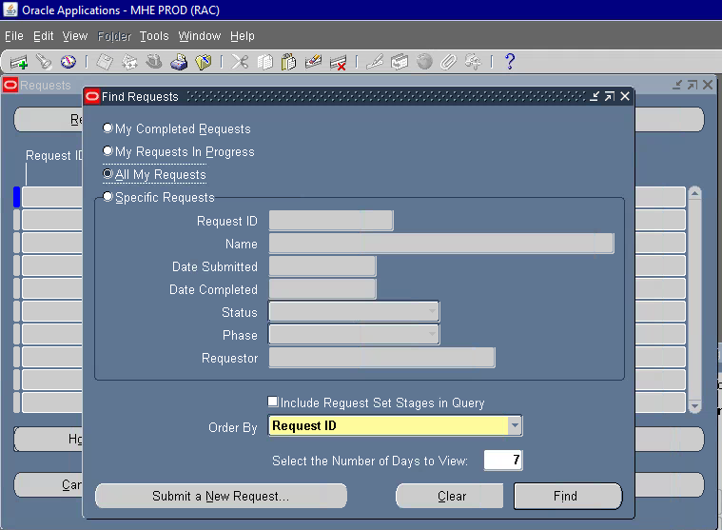

Click on Find, Select the request and click on View Output and save the output file in the below mentioned path for payment method “USD-CREDITCARD-HPI-02013” and “USD-CREDITCARD-SEG-02013”

R:\share\CRR\shared\CC Info\Credit Card Allocation\2016 CR CARD ALLOCATION

Create a folders in the above path with name 03 March 2016>MHE>Oracle Reports>Oracle Dump.

For payment method “USD-CC-HPI-PAYPAL” & “USD-CC-SEG-PAYPAL” the path is as follows

R:\share\CRR\shared\CC Info\Credit Card Allocation\2016 CR CARD ALLOCATION\PayPal

Create a folders in the above path with name 03 March 2016 and save files names accordingly for HPI & SEG.

R:\share\CRR\shared\CC Info\Credit Card Allocation\2016 CR CARD ALLOCATION\Braintree

Create a folders in the above path with name 03 March 2016 and save the files

Open a new excel sheet, click on open and select the file we are working on then select open.

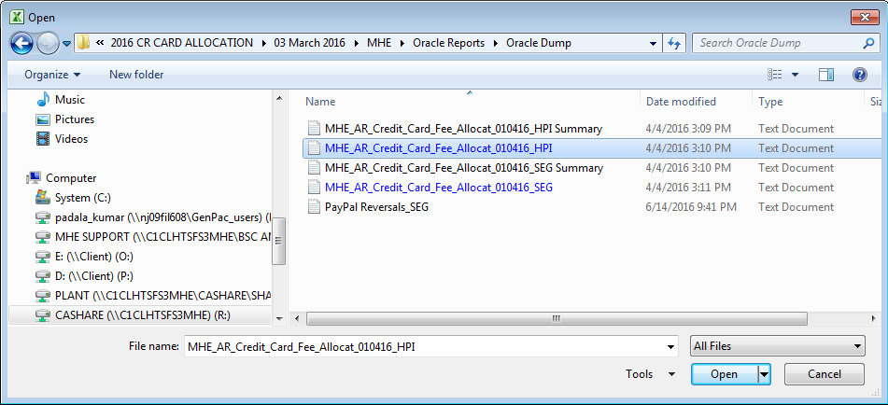

Detailed files saved under the respective paths
Select Delimited and then Next
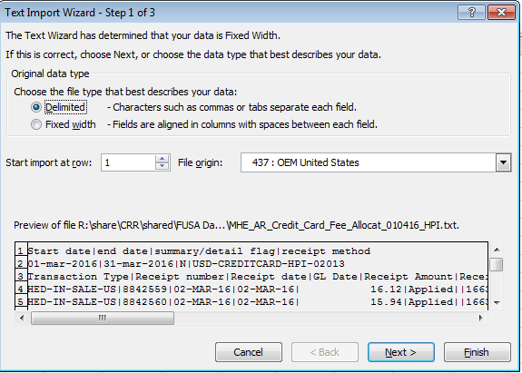

Give the Criteria based upon the special character appears in the format for example we can see “|” in this case so mentioned the same in Others option

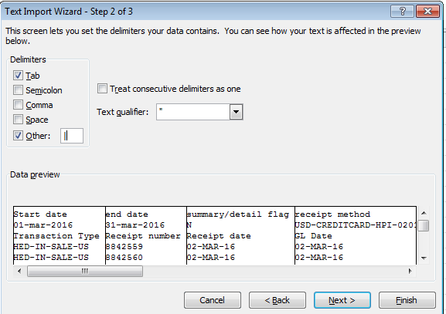

Now select the column and change the format as mentioned below:

Transaction Type - General
Receipt number - General
Receipt date – Date (DMY)
GL Date – Date (DMY)
Receipt Amount - General
Receipt status - General
Reversal Date – Date (DMY)
Batch - General
Customer Number - General
Customer Name - Text
Credit Card Number - Text
Payment server Order Number - Text
Transaction Number - Text
Amount applied – General

And then click on Finish
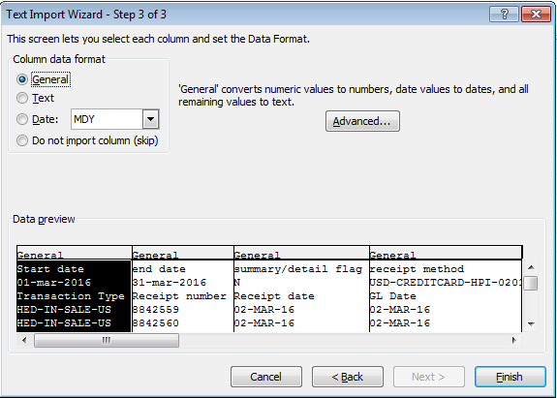

Delete the top two rows and insert a new column at the beginning and name it as month

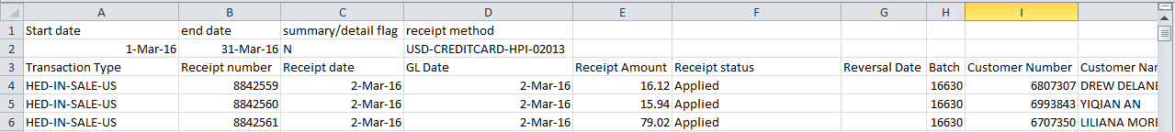

Go to Column P and for the first line enter formula “=LEFT(L4,1)” and in Column Q enter formula “=RIGHT(L4,4)”
Drag down till the last transaction line and then copy and past the date which will be in general format which should not be converted to numbers.

Do custom sort by Credit Card Number and then select OK when we get the following popup with option “Sort numbers and numbers stored as text separately” checked.
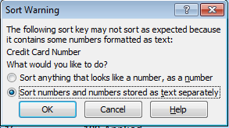

If information isn’t in correct columns Move into correct columns - (Check whole file to make sure everything is in correct columns)

Delete the column with name “Credit Card Number”

Select the Receipt numbers column and make sure to delete the Characters “IEX_” and “”CC”.

Take grand total of the amount applied column and name the sheet as “Sales”

Copy the headings row from the previous months reconciliation sheet and paste to the current month headings row and make sure the fields are under the correct headings.

Do a number filter for “Receipt Amount” which is less than zero (this includes all negative) and copy the data and save it in the next sheet and name it as “Refunds” and

The Third sheet should be the Subledger account balance screen-shot with name “Oracle Screen”.

Next sheet will be “Reversals Report” which is the export of previous three months GL Dates Reversal status report from the Receipt Summary.

Login to Citrix > Login to Oracle 11i with the credentials and then select the Responsibility “MHE – Receivables Manager1 – USA”

From the Navigator select Receipts Summary from Receipts
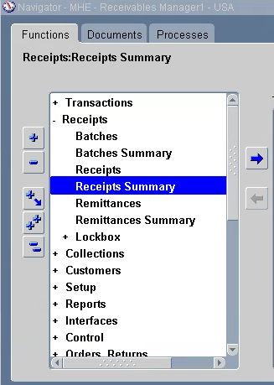

Click on Flashlight or go to View and click on Find, the following screen appears
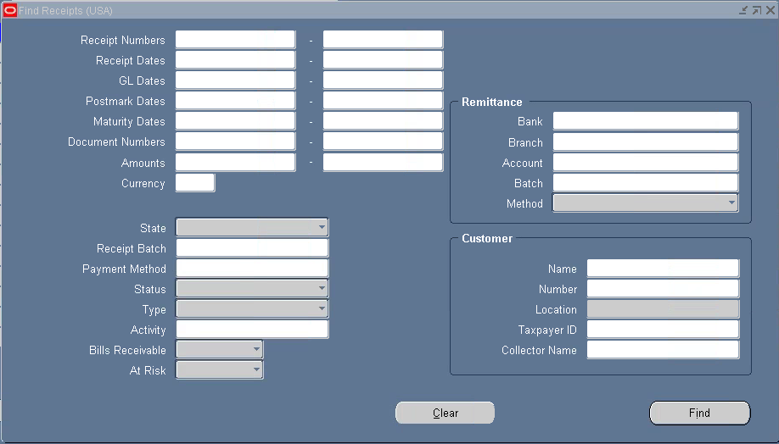

In the GL Dates field enter 3 months prior date (There are times you may need to run the reversals report farther back) example if we are doing the reconciliation for March month then the GL date range should start from 01-DEC-2015 to 29-FEB-2016

Payment Method:
USD-CREDITCARD-HPI-02013 (For Regular HPI Credit Card Payments)
USD-CREDITCARD-SEG-02013 (For Regular SEG Credit Card Payments)
USD-CC-HPI-PAYPAL (For PayPal HPI Credit Card Payments)
USD-CC-SEG-PAYPAL (For PayPal SEG Credit Card Payments)
USD_CC_HPI_PAYPAL_AMS (For Brain Tree HPI Credit Card Payments)
Status – Reversed

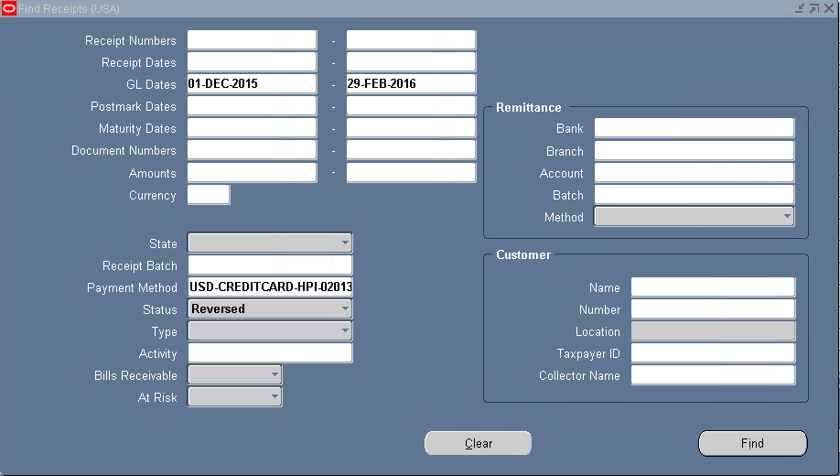

Click on Find

When file comes up go to Folder on toolbar > select “Show Field” to insert Reversal GL Date and Reversal Date fields

Go to File and click on Export

File Download – Save

Open > Copy the entire data> Paste it to excel sheet with sheet name as “Reversals Report”

Data Sort

Reversal GL Date Ascending - Look for month you are balancing in the reversal GL date column - Post totals to sales spreadsheet the opposite of what it is on reversals spreadsheet

Do Filter by Reversal Date and the Reversal GL Date which falls in the month reconciliation for example if we are working for March Reconciliation the if something appears to be in the month of March then we need to consider the total of the same

Open Journal Ledger Inqire and click on Account from Oracle

Enter the month and year working on

Provide the Subledger GL String which is as follows:
For HPI #501.0077.999999.0411310001
For SEG #501.2179.999999.0411310001

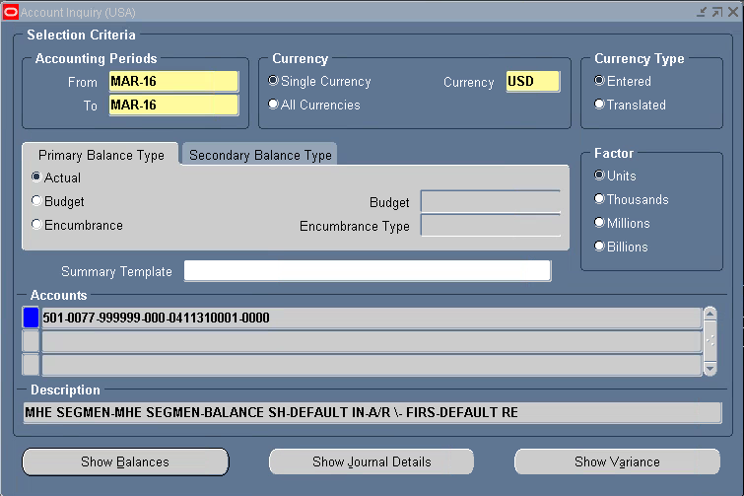

Click on Show Journal Details and for which ever transaction the Journal Entry field shows as “Credit Memo USD or Debit Memo USD” do a Drilldown of all those transaction and save it in the sheet named “CC Refunds”

All the above steps need to be followed for the PayPal Detailed report and need to be added to the lines of HPI i.e.,

For HPI Sales and Refunds should include both USD-CREDITCARD-HPI-02013 & USD-CC-HPI-PAYPAL
For SEG Sales and Refunds should include both USD-CREDITCARD-SEG-02013 & USD-CC-SEG-PAYPAL
payment methods

Go to the first Sheet name Sales and in the bottom Create a table as shown below with the totals linked to the respective sheet names
For SEG the format should be as below:

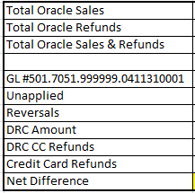

Total Oracle Sales -Total Oracle Refunds=Total Oracle Sales & Refunds

Total Oracle Sales & Refunds (includes Paymentech, PayPal and Braintree)
(-)GL #501.0077.999999.0411310001
(-)Unapplied
(-)Reversals
(-)DRC CC Amount (If any are contributing for the current GL Total)
(-)DRC CC Refunds (If any are contributing for the current GL Total)
(-)Credit Card Refunds
=Net Difference (which should be zero)

For the DRC CC Amount and Refund We have to copy the data from the Total Cash report for the month and Enter new sheets.

For HPI the format should be as below:

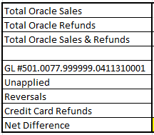

Total Oracle Sales -Total Oracle Refunds=Total Oracle Sales & Refunds

Total Oracle Sales & Refunds (includes Paymentech, PayPal and Braintree)
(-)GL #501.0077.999999.0411310001
(-)Unapplied
(-)Reversals
(-)Credit Card Refunds
=Net Difference (which should be zero)
Save the files in the path R:\share\CRR\shared\CC Info\Credit Card Allocation\2016 CR CARD ALLOCATION\03 March 2016/MHE/Oracle Reports

With the name as Oracle Credit Reco March Month _HPI for HPI and for SEG Oracle Credit Reco March Month _SEG

- Process Exceptions Handling
- None

- Compliance control
- None

- Escalation process
- System related issues would be escalated to IT helpdesk
- Process related issues would be escalated to Line manager.

First Level of Escalation:

Offshore-Genpact Manager-Bhavsar Parth-Parth.Bhavsar@mheducation.com

Second Level of Escalation:

Onshore-Director, AR Operations-Luckie Kathy-kathy.luckie@mheducation.com

- Process SLAs
- None

- Related Documents
- None

- FAQ:
- None

- Sign Off.

Kathy Luckie 10/29/2020

